Parent Curriculum Overview
Autumn Term 2 2020 Class 4
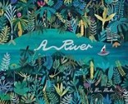  ENGLISH  This half term we will be developing our understanding of non-fiction through a poem called A River. We will also have a fiction focus, developing our storytelling. We are going to explore how to use sentence length to change the atmosphere and add detail. In the new curriculum, spelling and grammar are essential and these skills should be reflected across all subject areas. Reading continues to be a high priority through the English sequences and in reading lessons. | 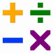  MATHEMATICS  This half term we will develop our understanding of the 4 number operations with a focus on Multiplication and Division. We will continue to model and encourage the children to be able to talk through their mathematical ideas. We will be using the children’s knowledge of their times tables to help them to solve problems in context. Learning times tables remains a high priority, with the children expected to know up to 12x12 by the end of year 4. Please support your child at home by practising these number facts regularly as part of the home learning.
SCIENCE  Our topic for this half term is Our topic for this half term is Electricity. We will be making different circuits and trying to create our own buzzer for a quiz. | 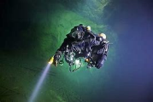  GEOGRAPHY  This half term our theme is Blue Abyss. We will be exploring life in the deep blue ocean. We will also be using an Atlas to locate and name the Oceans and Seas.
PE  This half term we will be completing 2 outside PE units. ​ We will be doing Dance and Fitness.​ We will have PE on a Tuesday afternoon and a Thursday Morning. The children will need their PE kits in school for Tuesday afternoon. On Thursday, the children will not change for PE but can bring trainers to wear. | 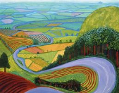  ART  This half term we will be completing an art project inspired by David Hockney. We will be looking at landscapes and creating our own landscape using the poem A River as inspiration. This half term we will be completing an art project inspired by David Hockney. We will be looking at landscapes and creating our own landscape using the poem A River as inspiration.
MUSIC  We will be looking at different percussion instruments. | RE  In RE this half term we will be exploring the key question What do Hindus believe God is like?
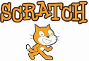  COMPUTING  This half term we will be focusing on Coding using the software Scratch. E-safety will also be a core feature of our Computing teaching. | PSHE  We will be using Jigsaw for PSHE. This half term our topic is ‘Celebrating Differences.’
MFL  Our French unit this half term is On the Move. We will be learning vocabulary about transport. | INFORMATION / KEY DATES  Our timetabled PE sessions are Tuesday and Thursday.
Water bottles must be brought to school every day – only water is allowed in class. Squash is allowed at lunchtimes only.
It is a requirement for Reading Journals to be in school every day. Please use these to relay messages to your class teacher. Your child is expected to read regularly at home and comment on their reading in their Reading School Link Books. Weekly spelling tests, TT Rockstars and doodle maths will form the homework each week along with one half termly creative project.

