Parent Curriculum Overview
Autumn Term 2 2020 Class 3
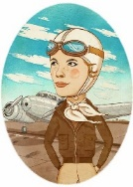  ENGLISH  In English this half term, we are looking at the text ‘Fantastically Great Women Who Changed the World’ and learning about famous women such as Rosa Parks, Amelia Earhart and Mary Anning. We will be writing biographies – can you think of a famous person you would like to write about? | 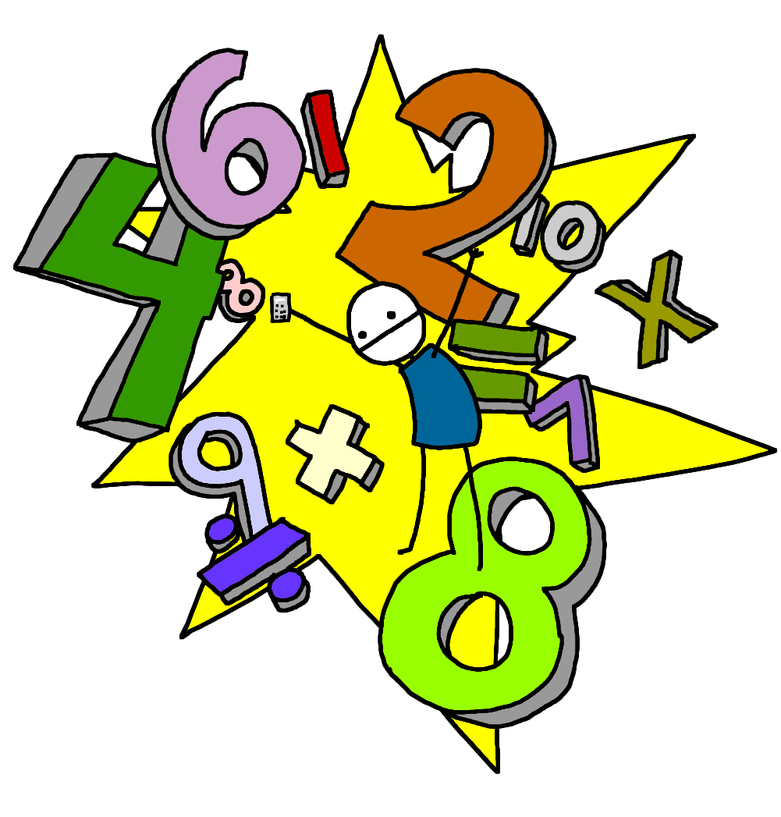  Maths  In maths we are continuing with our Addition and Subtraction unit and starting to use the column method to work out how to calculate 3-digit numbers. After this we will be moving on to Multiplication and Division – we need to know our 2s, 5s, 10s, 3s, 4s and 8s by the end of the year. Keep working on Timestable Rockstars!
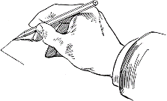  Art  Our Art topic is linked to our geography topic of Rocks, Relics and Rumbles – we will be exploring textures of different fossils and recreating them by using different sketching techniques. We will also be making our own recreations of fossils using clay and salt-dough. | 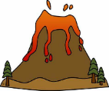  Geography  Our topic this half term is ‘Rocks, Relics and Rumbles’. We will be learning all about the layers of the earth and how volcanoes are formed. We will be creating 3D labelled models of volcanoes and re-creating a volcanic eruption along with comparing different places in the world with volcanic activity. What do you already know about volcanoes?
COMPUTING  In computing with Ms Kellman, we will be learning how to send and receive emails and deepen our understanding about being safe online. | 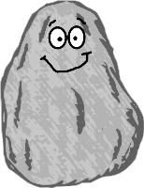  SCIENCE  Our topic in Science this term is linked to our Geography topic – we will be learning all about rocks and investigating different types and their uses in everyday life.
RE  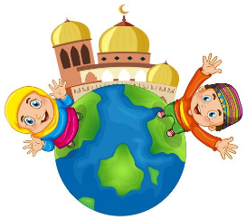  This half-term in RE we are learning all about Islam – specifically about how and why festivals are special to Muslims. We will be making and tasting foods that are commonly eaten during the festival of Ramadan! | PE  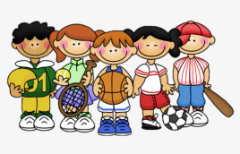  On Fridays we will be carrying on with Fitness with Miss Angell by working on our core strength and designing our own workouts. On Mondays with Ms Kellman we will be learning a dance routine and different ways to move our bodies!
PSHE  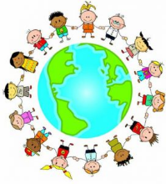  Our PSHE unit is ‘Being Me in My World’. It will involve getting to know each other, discussing what would make our school a better place, discussing rewards and consequences and discussing how to learn at our best. We will be following the ‘Jigsaw’ scheme of work. | 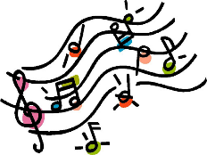  MUSIC  This half term in Music we will be working with Ms Kellman learn some Christmas songs along with improving our percussion skills.
MFL  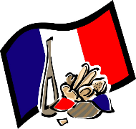  In MFL with Ms Kellman we are continuing with our French lessons. We will be learning how to explain and describe our lives – all about me and my family. We will also be learning to talk about where we live. | Home Learning and important information  - PE days will be Mondays and Fridays although PE Kit will only be needed on the Friday.  - Our Home Learning for the half-term will be based around our topic of Rocks, Relics and Rumbles. If you would like to bring in some home-learning for show and tell, please bring it in on Fridays.

