Parent Curriculum Overview
Autumn Term 2 2020 (Year 2)
ENGLISH  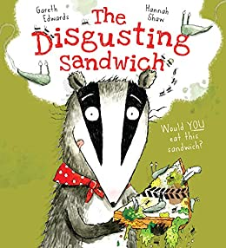  This half term we are placing more emphasis on Read Write Inc to support our reading, spelling and grammar. There will be daily writing sessions which require pupils to complete a short task based on a certain text. In these writing sessions, we aim to promote a love of reading and writing through discussions, role play, hot seating, performing and more exciting activities. The first book we will be looking at is “The Disgusting Sandwich”. We will also be continuing with our weekly spellings. | MATHEMATICS  This half term we will be exploring different ways of representing addition and subtraction of number. We aim to increase pupil’s fluency of number bonds within 100.  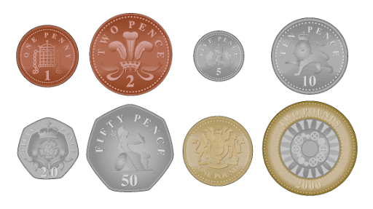  We then aim to look at different units/measure of number such as money and apply this to our knowledge of addition and subtraction.  At the end of the half term we will be looking to introduce multiplication and division.
SCIENCE  Our new science topic is based on “everyday materials”. We will be looking at materials around us and their various uses. At the end of this topic, pupils will be able to build their own model home using a range of different materials. | TOPIC (GEOGRAPHY)  Our topic for this half term is “coastline” which is a geography-based topic. We will be investigating a range of coastal features that we can see around the United Kingdom. We will then use a range of sources to research coastal areas in the city of Plymouth.
COMPUTING  In computing we will be learning about different uses of word processing such as creating posters, leaflets, newspapers and more. | Design and Technology  In D&T we will be looking at building a range of different structures. At the end of the module each pupil will have the opportunity to create a model beach hut.
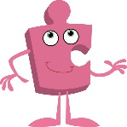  PSHE  Our half term topic for PSHE will be “Celebrating Difference”. This is the next unit in our Jigsaw programme which our new mindfulness approach to PSHE this year. This is an important module as this teaches children about forms of bullying, how they can be prevented and how they can be overcome. | 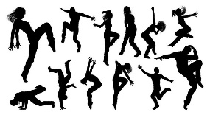  PE  This half term, our two units will be “Dance” and “Fitness 2”. Our timetabled PE days are Tuesday and Thursday. We ask that you bring in full PE kit to get changed into on Tuesdays (for dance). On Thursday, the pupils will not need to get changed however they can put on some trainers instead (for fitness).
RE  This half term we will be exploring and comparing Christian and Muslim beliefs. | MUSIC  Our music lessons will be looking at traditional carols which encourages the pupils to create and participate in a range of activities based on these.
Home Learning  All pupil reading journals will need to be brought into school every day. Please ensure your child regularly reads at home and comment on this in their reading record books. To change your book, you need to have read it through three times. I will be offering lots of dojo points to regular readers. Every week there will also be spellings to learn and the expectation that you child spends at least 10 minutes a day on doodle maths. | Important Information  We recommend bringing in a healthy snack for morning break. It is recommended that water is brought into school for daily use during class. Squash will be allowed at lunchtime only.

