Curriculum overview Autumn 2 – Year 1
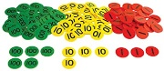  Maths  This term we will be exploring addition and subtraction 1-10, place value 1-20 and geometry: shape. We will be looking at how we can manipulate numbers and change them by adding and subtracting. We will also be building on our place value knowledge of 10 up to 20. Like last term, we will be exploring these in a variety of contexts. Finally we will explore shape, we will explore names, properties and look for them in our own environment. | 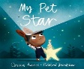  English  We will be writing in our English lessons 3 times a week, using a short burst teaching style. We will be still be basing our writing activities around stories. Some of our key stimuluses will be ‘My Pet Star’ and ‘The Man and on the Moon’. Throughout this term our key focus will be learning to write simple sentences whilst applying our phonics from our Read, Write, Inc lessons.
Phonics  Read, Write, Inc is continuing at Buckfastleigh school for 1 hour a day. It is a structured programme that teaches children to read. Children will be placed in stage, not age groups, which means that everyone will be at the perfect challenge level for their next step of learning. Children are taught sounds and then supported to read them then apply them when spelling. | Science  Our theme for science is ‘materials.’ We will be exploring what things are made from and why. We will be describing the properties of materials and then experimenting which materials are fit for purpose. We will be creating our own teddy umbrellas, so we will need to find out which material is the most waterproof.
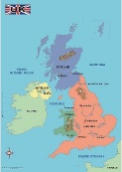  Geography  In geography our topic will be ‘Bright Lights and Big Cities.’ We will be exploring the four countries that make the UK and exploring human and man-made features within our own environment. | 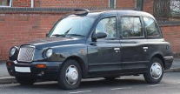  Design Technology  Our D + T focus this term will be linked to our Geography. As we explore London landmarks we will be creating our own taxis. These vehicles will have working axles and wheels.
PE  Our PE day is Thursday (full PE kit). We will then be exploring dance with Mr Pepper on a Friday (just shoes required) | 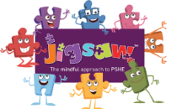  PSHE  We will be using Jigsaw for PSHE. This half term our topic is ‘Celebrating differences’
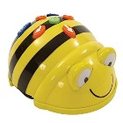  Computing  Our main focus for computing this term will be learning how to programme. We will be programming bee-bots and learning about functions and capabilities. | Music  Our title for music this term is “Rhythm in The Way We Walk and Banana Rap.” We will continue to build on our rhythm skills from last term.
Key information:
Water bottles must be brought to school every day – only water is allowed in class. Squash is allowed at lunchtimes only. Our PE day is Thursday, full kit is required. Morning snacks must be fruit, vegetables or cheese only. Please ensure all school uniform and PE kits are labelled with your child’s name.
Reading books and logs are required to come into school every day. Please support your child by reading at home. Reading books will be changed most days. Whilst your child is reading blending books we will change them after 1 read but they will be given out more than once to help your child become really familiar with reading those words. When your child is reading story books we suggest three reads, over three days. This is to develop a deep understanding of what is being read and to build fluency and speed.

