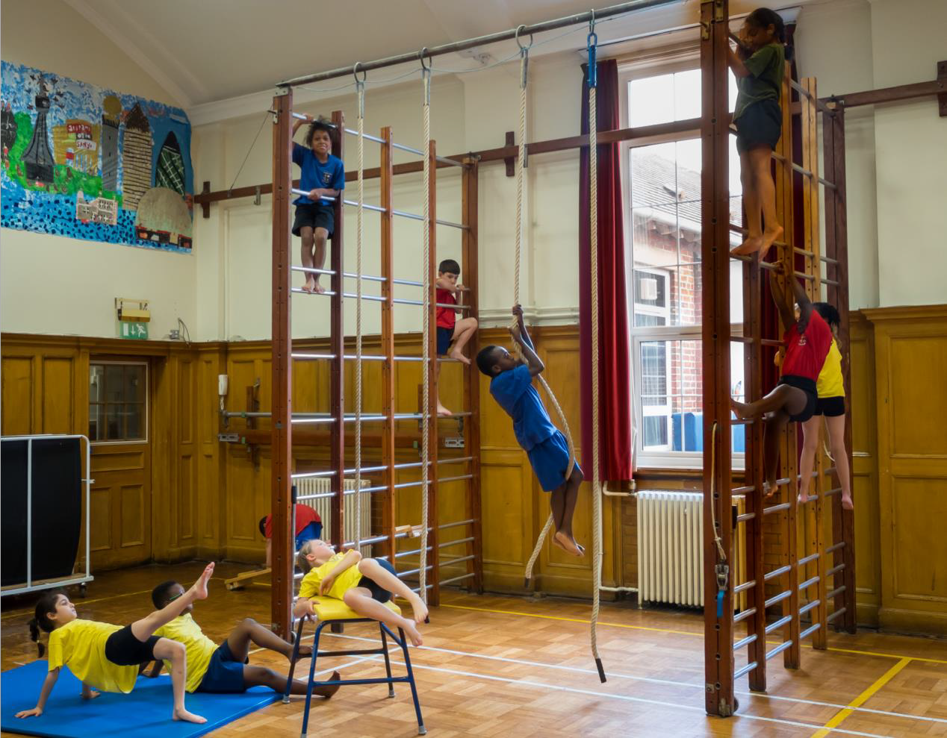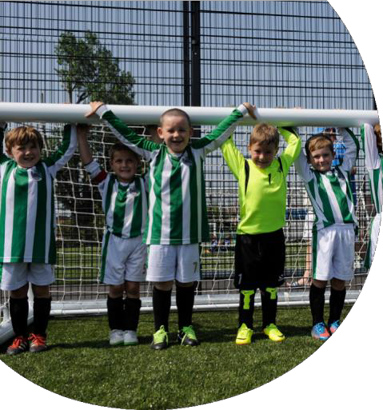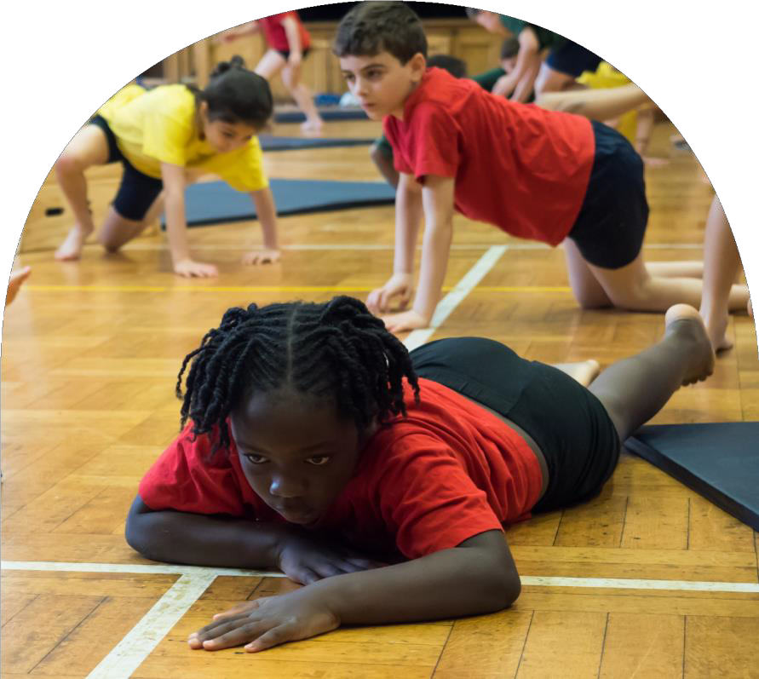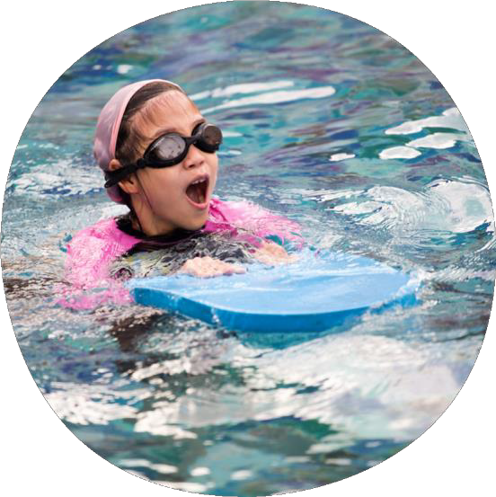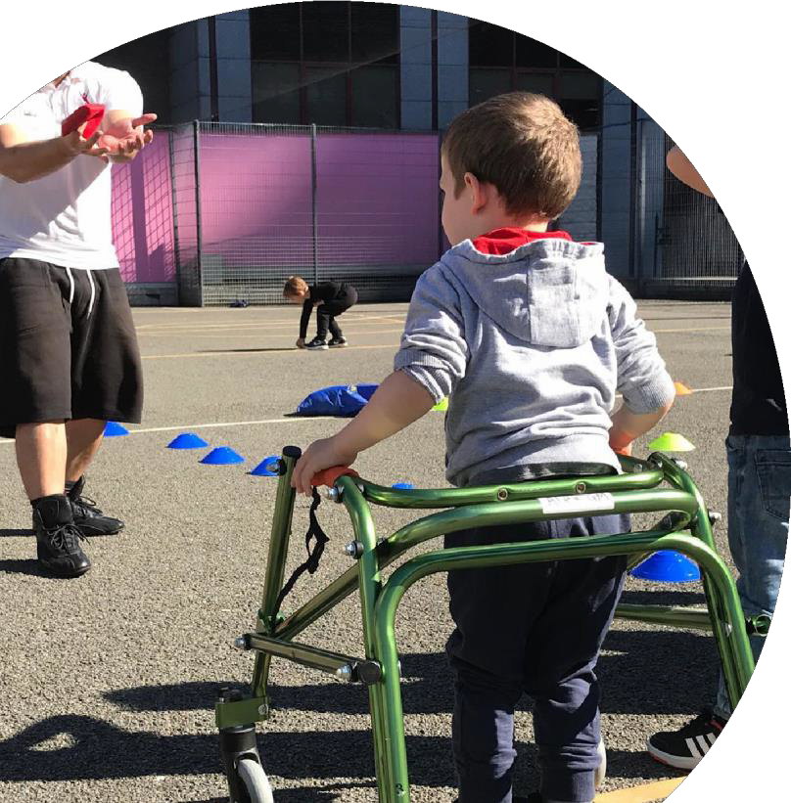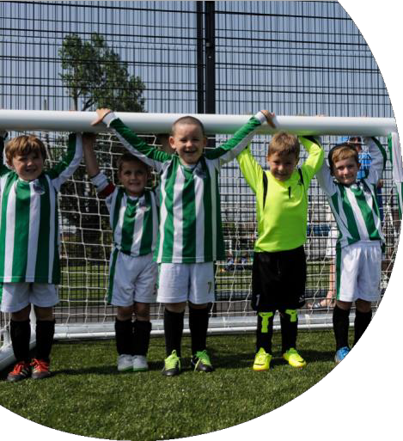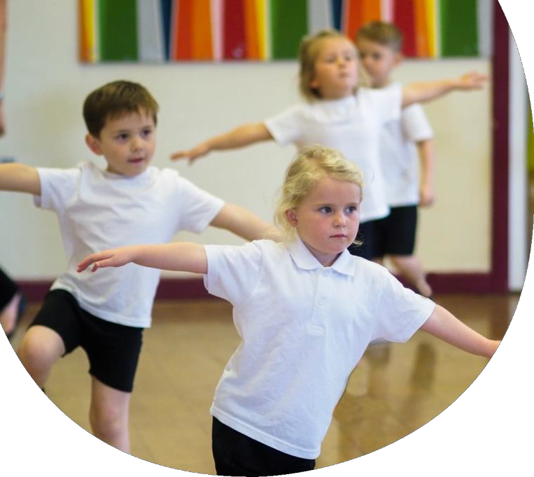
Evidencing the Impact of the Primary PE and Sport Premium

Website Reporting Tool
Revised October 2018

Commissioned by
Department for Education
Created by

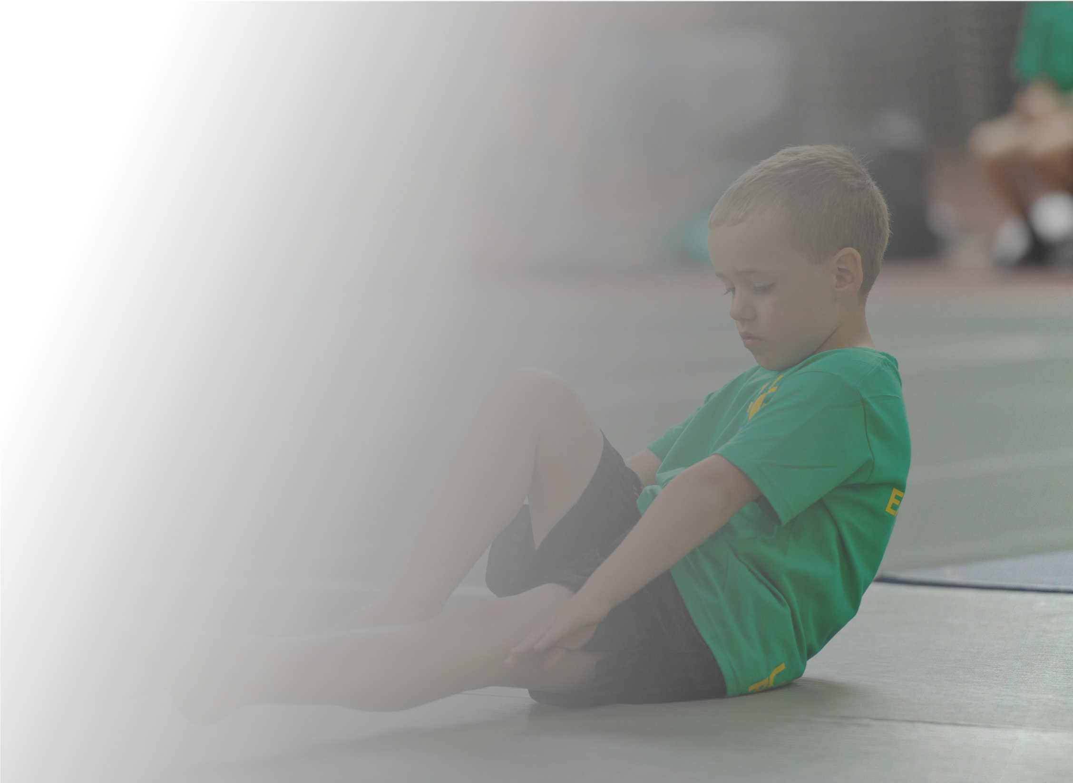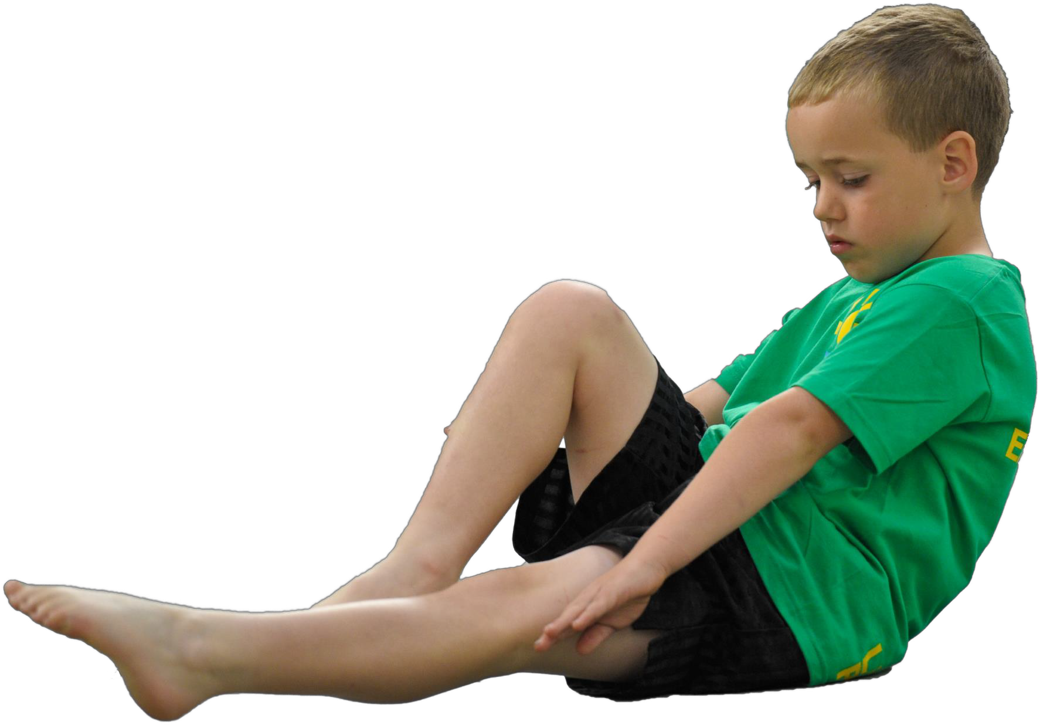Schools must use the funding to make additional and sustainable improvements to the quality of Physical Education, Sport and Physical Activity (PESPA) they offer. This means that you should use the Primary PE and Sport Premium to:

- Develop or add to the PESPA activities that your school already offer
- Build capacity and capability within the school to ensure that improvements made now will benefit pupils joining the school in future years

Please visit gov.uk for the revised DfE guidance including the 5 key indicators across which schools should demonstrate an improvement. This document will help you to review your provision and to report
your spend. DfE encourages schools to use this template as an effective way of meeting the reporting
requirements of the Primary PE and Sport Premium.

We recommend you start by reflecting on the impact of current provision and reviewing the previous
spend. Under the Ofsted Schools Inspection Framework, inspectors will assess how effectively leaders use the Primary PE and Sport Premium and measure its impact on outcomes for pupils, and how effectively governors hold them to account for this.

Schools are required to publish details of how they spend this funding as well as on the impact it has on pupils’ PE and sport participation and attainment by the end of the summer term or by 31 July 2019 at the latest.

We recommend regularly updating the table and publishing it on your website throughout the year, as evidence of your ongoing review into how you are using the money to secure maximum, sustainable impact. To see an example of how to complete the table please click HERE.

Created by: Supported by:

Support for review and reflection - considering the 5 key indicators from DfE, what development needs are a priority for your setting and your students now and why? Use the space below to reflect on previous spend, identify current need and priorities for the future.

Key achievements to date: | Areas for further improvement and baseline evidence of need:
Curriculum:  All staff share a clear understanding of the importance of PE and School Sport in the curriculum.  Teachers provide a broad curriculum that interests the children and enables them to access PE and School Sport.  PE has a high profile within the school and children are keen to participate in their learning.  Participation:  Collaborating with other schools and colleagues to promote and develop school sport as part of the Dartmoor Schools Sport Partnership.  Children attend a range of sporting competitions and events.  Opportunities:  Providing high quality outdoor play equipment for the children to use Lunchtime support and activities to encourage children to have active playtimes.  Leadership opportunities for children to lead and support others to be active.  Swimming:  An effective swimming support program to ensure that children achieve the  required expectations at the end of K2 | Increase participation of girls in school sport. Sustain participation in competitive events.  Identify ways to ensure that all children are clear of the progress they are making during PE lessons.  Maintain PE equipment to ensure that high quality learning and teaching can be facilitated.

Meeting national curriculum requirements for swimming and water safety | Please complete all of the below:
What percentage of your current Year 6 cohort swim competently, confidently and proficiently over a distance of at least 25 metres?  N.B. Even though your children may swim in another year please report on their attainment on leaving primary school. | Confirmed 96% (July 2019)
What percentage of your current Year 6 cohort use a range of strokes effectively [for example, front crawl, backstroke and breaststroke]? | Prov 96%
What percentage of your current Year 6 cohort perform safe self-rescue in different water-based situations? | Prov 96%
Schools can choose to use the Primary PE and Sport Premium to provide additional provision for swimming but this must be for activity over and above the national curriculum requirements. Have you used it in this way? | Yes

Action Plan and Budget Tracking
Capture your intended annual spend against the 5 key indicators. Clarify the success criteria and evidence of impact that you intend to measure to evaluate for students today and for the future.

Academic Year: 2018/19 | Total fund allocated: £18 010 | Date Updated: | July 2019
Key indicator 1: The engagement of all pupils in regular physical activity – Chief Medical Officer guidelines recommend that primary school children undertake at least 30 minutes of physical activity a day in school |  |  |  |  | Percentage of total allocation:
 |  |  |  |  | 46%
School focus with clarity on intended impact on pupils: | Actions to achieve: | Funding allocated: |  | Evidence and impact: | Sustainability and suggested next steps:
To provide lunchtime opportunities for children to engage in a range of physical activities  To enable all children to achieve the required standard for swimming at the end of KS2  Sports Apprentice is also our Swimming Instructor (Swimming instruction not paid out of Sports Premium) | Employ a Sports Apprentice to develop active lunchtimes (and to enhance PE in KS1 and in After School Club)  Provide additional sessions for children in years 5/6 in addition to their curriculum PE sessions | £8110  £150 |  | Increase in activity and participation for all children at lunchtimes.  All children to achieve the required standard for swimming at the end of Key Stage 2- Outcome was only one child (who joined us in Y6) did not meet standard however she now has confidence to visit the community pool outside of school. | Children to be taught games and activities that they can play/can be led by Play Leaders at other times  Children to have confidence to visit community pool out of school

Key indicator 2: The profile of PESSPA being raised across the school as a tool for whole school improvement |  |  |  | Percentage of total allocation:
 |  |  |  | 26%
School focus with clarity on intended impact on pupils: | Actions to achieve: | Funding allocated: | Evidence and impact: | Sustainability and suggested next steps:
To be part of the Dartmoor School Sport Partnership to continue to raise the profile of PE and sport in the curriculum | Buy into SSP  Attend PLT meetings/PE conference to enable the PE coordinator to work collaboratively with other schools and keep informed of the latest developments in PE and school sport | £4750 | PE priorities are highlighted on Whole School Development plan  Governors are informed of PE developments and priorities and monitor progress  PE coordinator to report to governors throughout the  academic year | Yearly review of impact of SSP  Regular meetings with SSCo (Becky Mason)  PE Coordinator (HR) to work with another member of staff (JC) in developing PE across the school
During this year through the work of DSSP the pupils of Buckfastleigh Primary school enjoyed: The Inspire Day at the Plymouth Life Centre, the amazing dance in Primary Body Language Year 1 dance sharing festival and the Year 4 Handball festival. Our Sports apprentice was also successfully supported as Gemima Kay-Savage completed her School Games Mark application, and was awarded a well deserved Bronze standard. This is a great benchmark to start with for next year.

Key indicator 3: Increased confidence, knowledge and skills of all staff in teaching PE and sport |  |  |  | Percentage of total allocation:
 |  |  |  | 2%
School focus with clarity on intended  impact on pupils: | Actions to achieve: | Funding allocated: | Evidence and impact: | Sustainability and suggested next steps:
Continue to provide high quality learning in PE for all children  Children to have clear understanding of the progress they are making in PE  Ensure access to a range of appropriate equipment | Sports Apprentice and Sports Lead coordinator to keep staff informed of new ideas and developments n the teaching of PE  Staff to attend INSET Handball sessions to support and develop the teaching of team games -curriculum focus area  Regular audit of equipment/ resources to ensure they are fit for purpose and in good condition | £400 (cover) | Children are able to discuss their learning and progress in PE  Monitoring/discussion with staff | Teachers to adapt teaching to ensure that children are all aware of the progress they are making  Feedback to next member of staff as part of transition process at the end of the year.

Key indicator 4: Broader experience of a range of sports and activities offered to all pupils |  |  |  | Percentage of total allocation:
 |  |  |  | 22%
School focus with clarity on intended  impact on pupils: | Actions to achieve: | Funding allocated: | Evidence and impact: | Sustainability and suggested next steps:
To enable children to experience alternative physical activities in a ‘club’ type set up. | Specialist Tae Kwan Do instructors giving weekly opportunities for KS2 and some Y2 children. |  | Increase in participation by all  Children taking part in different types pf sports/activities.  Some children have joined clubs outside school and have achieved official gradings at an excellent level. | Children sign-posted to clubs and organisations to develop new skills  Consider running Kick Boxing in 6 week blocks across different class groups.
 |  | £3900

Key indicator 5: Increased participation in competitive sport |  |  |  | Percentage of total allocation:
 |  |  |  | 4%
School focus with clarity on intended  impact on pupils: | Actions to achieve: | Funding allocated: | Evidence and impact: | Sustainability and suggested next steps:
To enable pupils to take part in competitive sports events  To increase the range of competitive  opportunities for children | Supply costs for staff to enable children to attend events  Transport costs for children to attend events | £700 | Participation of children across KS2 | Promote success and achievements through school newsletter/displays  Encourage children to progress and make links with local sports clubs

